Project: Spaghetti & Marshmallow Exercise
Instructor: Ms. Ellis
Objective: To encourage students to work together to practice several design thinking mindsets: Radical Collaboration, Bias to Action, Build to Think, Failing Fast, Test and Iterate. The Spaghetti Marshmallow activity is designed to get students working together to build and test their designs with an emphasis on radical collaboration and bias to action. This exercise is a great way to push students to build, test and iterate. This activity also encourages critical thinking by asking students to synthesize what they learned quickly to create new designs. Students must also demonstrate resilience in the face of challenges or frustrations. Today, Students will work together to practice the Prototype, Test thinking mode.
Brief: Build the tallest freestanding tower you can in 10 minutes.
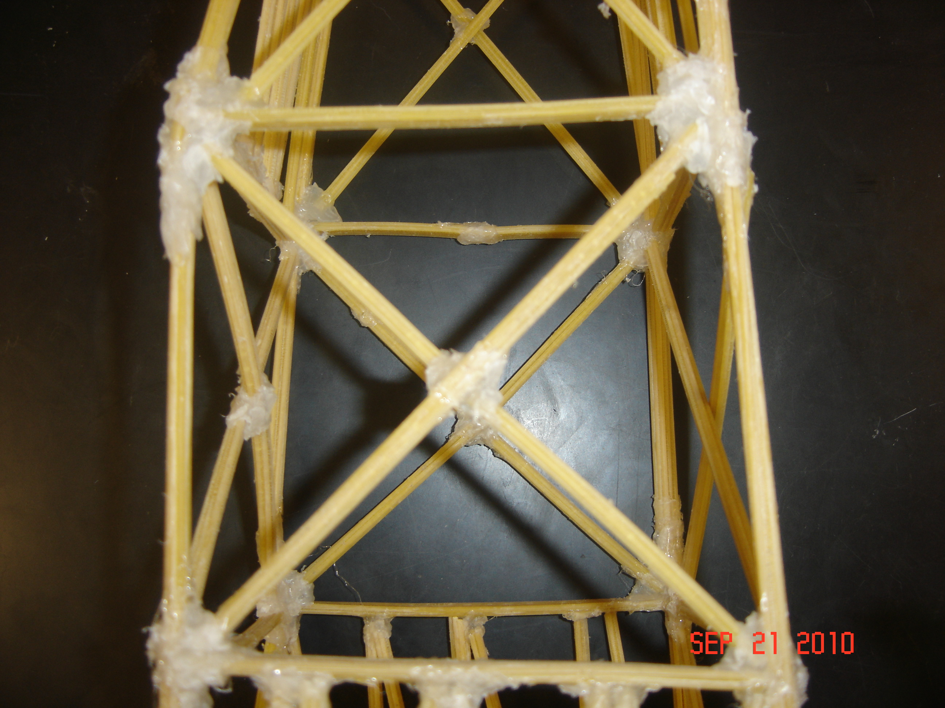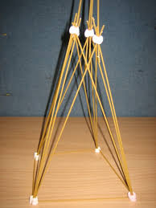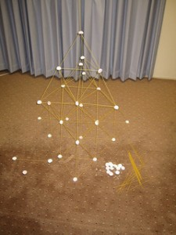

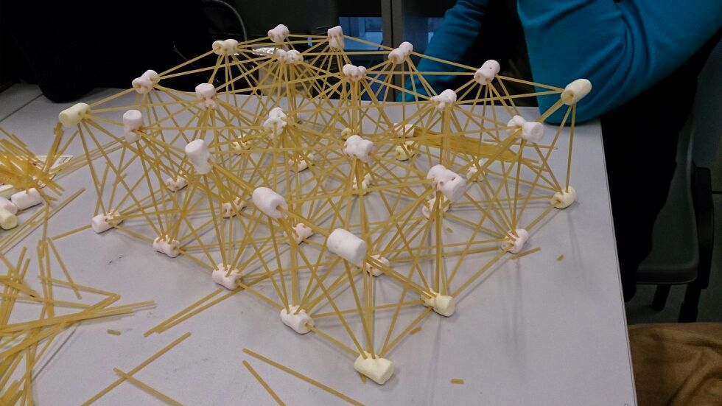

Difficulty:
Beginner Duration: 45 minutes Group Size: Groups of 3-4, up to 40 participants

Brief: In groups of four, build the tallest freestanding tower you can in 10 minutes using only these materials.

Materials:
Each group gets:
• 20 pieces of spaghetti
• 1 marshmallow
• 1 yard of string
• 1 yard of tape

Instructions:
Teamwork Exercise Introduction - 5 minutes
• We are not going to get to go through the entire design process today, but instead, we are going to focus on prototyping and testing
• Also going to focus on teamwork and bias to action
• What is bias to action?
• At the d.school we believe in prototyping using cheap and easy-to-find materials. If you build something made out of expensive materials, put a ton of work into it, and then take it to the testing phase you are less likely to accept the constructive feedback and change, or iterate, your design.
• In your groups of four you are going to be building/prototyping a structure using really basic materials: 20 sticks of spaghetti + one yard of tape + one yard of string + one marshmallow

Your design challenge - 10 minutes
In groups of four, build the tallest freestanding tower you can in 10 minutes using only these materials
• Use online timer to show passage of time
• If extra time, have groups try a second iteration.
• Measure Towers - Winners receive stickers! - 5 minutes

Debrief activity - 10 minutes
• What was the hardest part of this challenge? Easiest? What have you learned?
• Why is testing so important? What would you do differently if you had the chance to rebuild the tower?
• This would be iteration- a step all designers take. Importance of bias to action, building and creating, then testing, then iterating! To be a successful designer you must be able to take feedback, see it as a gift use the feedback to better your design. Take risks, be creative, try new things, etc.
• Many people spend most of their time planning and very little time testing. When you work this way, you risk your prototype failing too late to make needed changes.

